# Lab 05_02 -- Chapter 05 -- Person

## Lab Description:

Complete Programming Project #2 on page 371. You start the project by working on self-test question #16 on pg312.

**Beginning pg 312, #16**

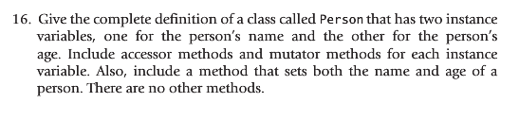

**Continued on pg 317, #2**

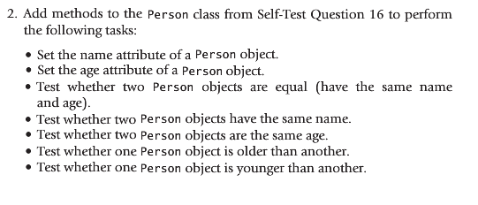

**Lab Requirements:**

1. The class should be named Person.java
2. The last three tests have to deal with comparing a person’s age. Perform all three age comparison tests in one method called compareAge(Person otherPerson).
   1. compareAge should return the number of years difference in age between the two people
   2. zero should be returned if the people are the same age
   3. a positive integer should be returned if **this** person is older than otherPerson
   4. a negative integer should be returned if **this** person is younger than otherPerson
3. Create a class, PersonDemo, to test your Person class
   1. PersonDemo should contain several instances of Person
   2. PersonDemo should test each of the methods in Person and in all combinations to verify the methods work as expected.
4. Use Java formatting conventions
5. Use comments where appropriate
   1. For example, method Pre and Post conditions
6. Challenge: Link your Person and StudentGrade classes, so a Person can have a StudentGrade and a StudentGrade must have a person associated with it
7. Submit your Person.java and PersonDemo.java classes to Blackboard.
   1. Remember, your submitted source code must compile or a zero will be given